Tenda MW5-Cannot manage MW5 when you open Tenda App. What should I do?

User Scenario：

It is the first time you configure MW5, “Connect to the WiFi network of a Tenda device” is showed when you open Tenda App even you connect with MW5 WiFi signal.

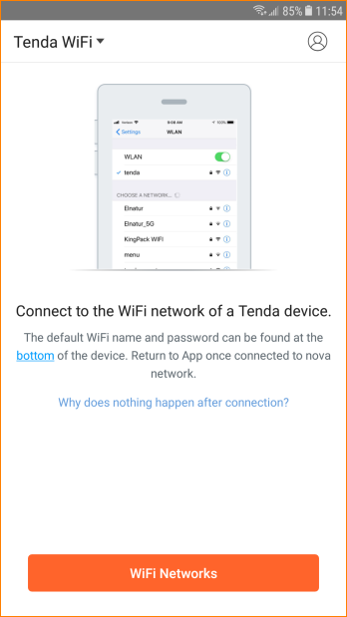

Reason 1:

MW5 is managed by other account.

Solution:

1.Login by correct account and use “Account Authorization” function.
Please refer to document “Tenda MW5-Another mobile phone wants to manage my MW5. What should I do?”
2. If you forget your account, please press the reset button for 6 seconds until LED blinking. Reconfigure the nova and login by your account.

Reason 2:

Mobile phone is connected with wrong WiFi signal.

Solution:

Please connect with correct WiFi signal.

